Part of Chinese Company List
(Companies in Yellow Remarks are recommended)

Company Name | Industry | Import / Export | Product Image
China Chamber of Commerce of Import and Export of Foodstuffs | Consumer Goods | Import | Need products involve all agricultural, forestry, food and farm products such as cereal, oil, oil seed, fresh and dried vegetable and fruit, poultry, meat, seafood, dairy, alcoholic beverages, soft drinks, tea, canned food, candy, honey products, mushroom, wood and etc.
Shanghai Minmetals Development Ltd.  www.shminmetals.com | Consumer Goods | Import | Founded in 1949, after nearly seventy years of development, Shanghai Minmetals has developed from a state-owned import & export company into a multi-domain integrated-service company providing both professional products and comprehensive trade service, with the annual revenue of over six billion yuan.
Bainuo Chocolates | Food | Export  Mylikes Chocolate | 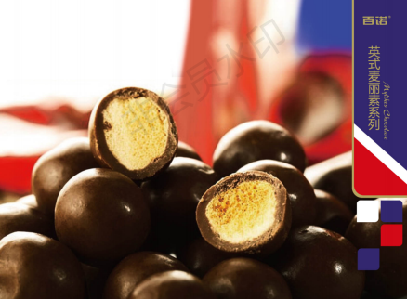
Shanghai Shang Hua Yuan Tian Le Industrial Co., Ltd. | Beverage | Export  Deuterium-depleted water | 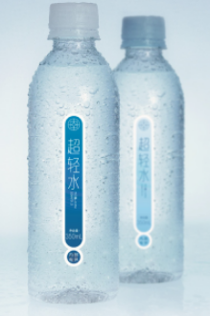
Foodchem International Corporation | Food & Beverage | Export  Beverage, bakery, candy, meat products and other food | 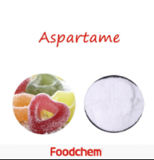
Shanghai Chaojixian Industrial Co.,Ltd. | Food & Beverage | Export  Food & Beverage | Shanghai Chaojixian Industrial Co.,Ltd. mainly engaged in food circulation; aquatic products, food and agricultural products sales; business information consultation; exhibition and display services; etiquette services; engaged in import and export business of goods and technology.
Shanghai Runhu Travel Articles Co., Ltd. | Consumer Goods | Export  Travel Essentials | 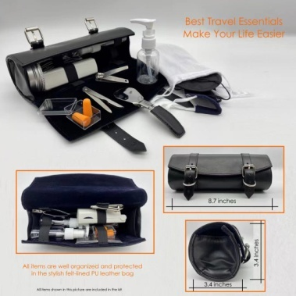
BLUE CHARM | Consumer Goods | Export  Customized Silk Scarf | 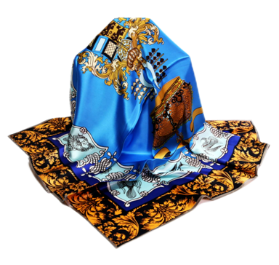
Shanghai Soap Co., Ltd.  http://www.ssccn.com/ | Consumer Goods | Export  Sandalwood- Made Products | 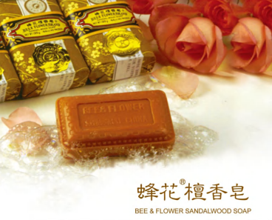
Shanghai LONU Optical Electrical Technology Co., Ltd, | Consumer Goods | Export  LED showcase lightings | 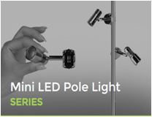
Shanghai Xianyuan Supply Chain Management Co., Ltd. | Consumer Goods | Export  Home Appliances | 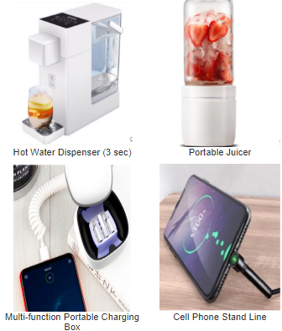
Shanghai Huasheng Weaving Co., LTD. | Consumer Goods | Export  Textile Fabrics | 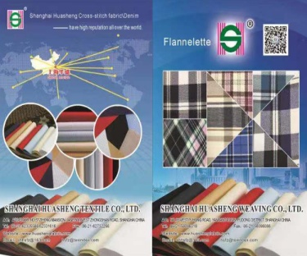
Shanghai Youmi Clothing Co.,Ltd. | Consumer Goods | Export  Clothing
Shanghai Wings International Trading Co., Ltd. | Consumer Goods | Export  Clothing
Shanghai Thoroughfare Business Management Services Co., Ltd. | Consumer Goods | Export  Aromatherapy
Shanghai Siyuan Fragrance and Flavour Co.,Ltd. | Consumer Goods | Export  Fragrance Flavor | 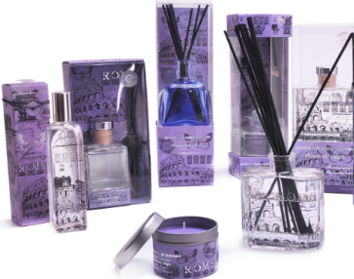
Shanghai Homes Bedding Co., Ltd. | Consumer Goods | Export  Bedding Products | 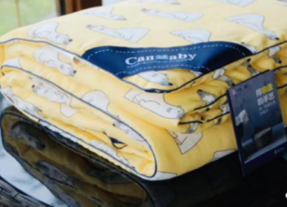
Shanghai Huide Science & Technology Co., Ltd. | Consumer Goods | Export  Synthetic material Products | 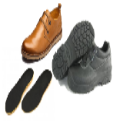
Shanghai INESA Scientific Instrument Co., Ltd.  www.inesarex.com | Intelligent Manufacturing Products | Export  Portable Multi-parameter Analyzer High quality versatile | 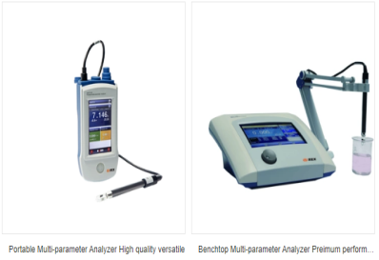
Shanghai Zhida Technology Development Co., Ltd.  http://www.shzhida.com | Intelligent Manufacturing Products | Export  Charger | 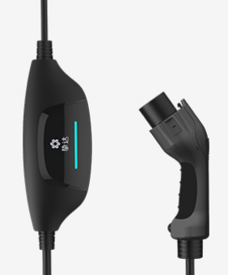
Shanghai Wangxun New Material Co., Ltd. | Intelligent Manufacturing Products | Export  Optic fiber cable | 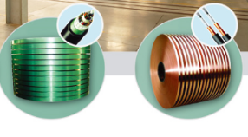
Shanghai Huaxiang Computer Communication Engineering Co., Ltd. | Intelligent Manufacturing Products | Export  Telecommunications and Communications Products | 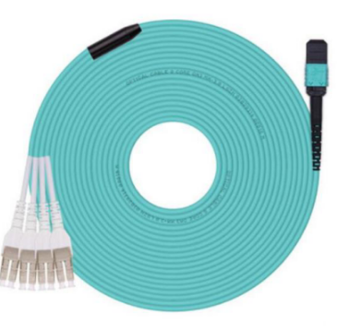
Shanghai Silin Special Equipment Co., Ltd. | Intelligent Manufacturing Products | Export  Aluminum Alloy Cable | 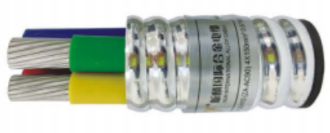
Shanghai Bluetech Co.,Ltd.  https://www.cn-bluetech.com/ | Intelligent Manufacturing Products | Import & Export  Water purification technologies and products | Shanghai Bluetech Co.,Ltd was founded in2003 and mainly undertakes research and development of water purification technologies and the production of drinking water filtration systems. The company upholds the ideals of making more healthy purified water with greater tastier.
Shanghai CANMAX Electronic & Mechanical Equipment Co., Ltd | Intelligent Manufacturing Products | Import & Export  Engineering machinery equipment | Shanghai CANMAX Electronic & Mechanical Equipment Co., Ltd is officially approved by Shanghai governmental foreign economic relations and trade commission, and we professionally operate imports, exports and sales engineering machinery equipment, etc.Our company is located in Shanghai which is a financial, trade and shipping center in china.
Shanghai Luchen International Economic & Trade Co.,Ltd. | Intelligent Manufacturing Products | Export  Food Machine | 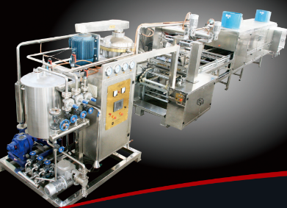
Shanghai Yuanchang Pharmaceutical & Chemical Equipment Co., Ltd. | Intelligent Manufacturing Products | Export  Pharmaceutical & Chemical Equipment | 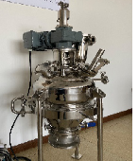
Shanghai Flying Automotive Equipment Co., LTD. | Intelligent Manufacturing Products | Export  Automotive Equipment and Accessories | 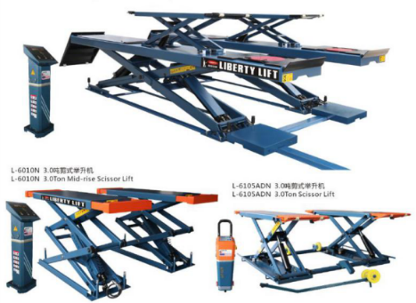
Oelincom Technologies Inc.  http://www.oelincom.com | Intelligent Manufacturing Products | Export  Fiber Optic Passive Components
Shanghai Renle Science & Technology Co., Ltd. | Intelligent Manufacturing Products | Export  Inverters, Soft Starters | 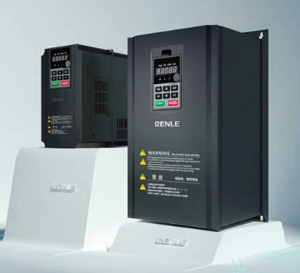
Shanghai YinRui New Energy Development Co.,Ltd. | Nonferrous Metals | Export  Electrolytic Cobalt | 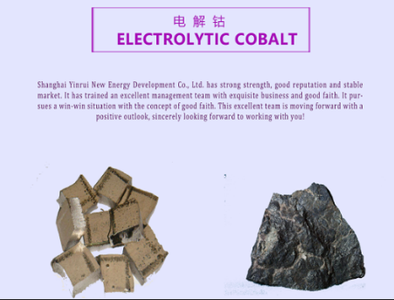
Shanghai Sunward Industrial Co.,Ltd. | Nonferrous Metals | Export  POF Film | 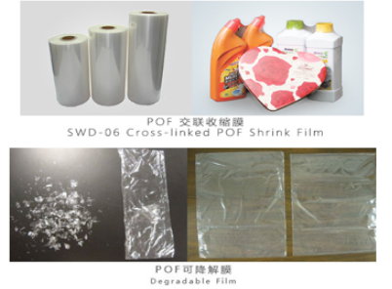
Shanghai FDL International Trading Co.,Ltd. | Nonferrous Metals | Import and Export various locks, hardware,material for packing, and various of machineries. | Shanghai FDL International Trading Co., Ltd. deals with various locks, hardware,material for packing, and various of machineries for importing and exporting.The company owns complete set of supplying channel.Products were exported to south east Asia,the middle east Europe,America and other regions.
Shanghai Somech Co., Ltd. | Nonferrous Metals | Export  Metal cutting, machine tools | 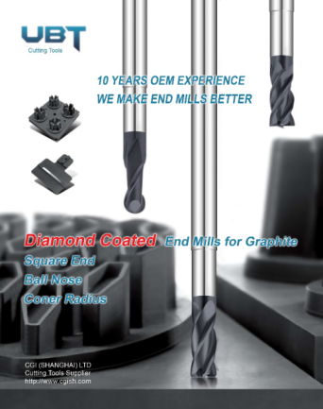
Shanghai DongHeXin Holdings Ltd. | Metals | Export  Tin plate | 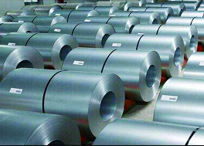
Shanghai Xinyutian International Trade Co.,Ltd. | Chemical Products | Export  Chemical raw materials | 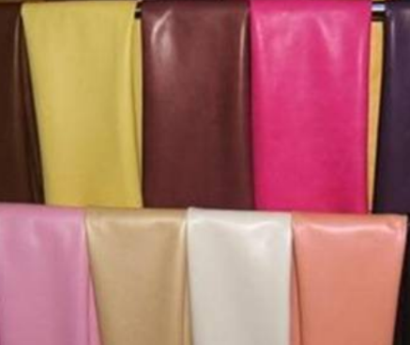
Shanghai Titanos Industry Co.,Ltd. | Chemical Products | Export  TIO2 | 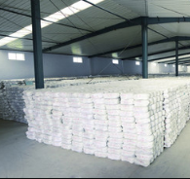
Shanghai KUMHO-SUNNY Plastic Co., Ltd.  http://www.kumhosunny.com/home | Chemical Products | Export  PC/ABS、ABS products | 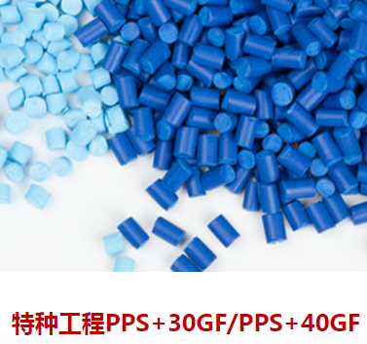
Shanghai Honesty Fine Chemical Technology Co.,LTD. | Chemical Products | Export  Fine chemicals | Shanghai Honesty Fine Chemical Technology Co.,Ltd. is a private enterprise mainly responsible for import and export business which is initiated in 2011. We engage in water based fine chemicals, such as emulsifier ,surfactants, functional additives and electronic chemicals, etc, mainly used in the emulsion for areas of latex, adhesive, paper, textile, ink, etc, or as additives and surfactants for higher performance products.
Haolisen Coatings (Shanghai) Co.,LTD.  http://www.haolisen.com/ | Chemical Products | Export  Paintings | 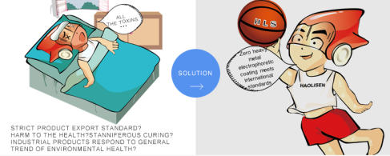
Shanghai Changyang Medical Technology Co., Ltd | Biomedicine and Medical Instruments | Export  Oral Ultrasonic Contrast,  Pet Medical Imagery Devices  Import  Medical Devices | 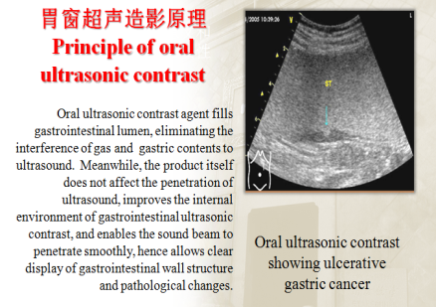
Shanghai Chancheng Biomedical Technology Co., Ltd. | Biomedicine and Medical Instruments | Export & Import  Medical Devices | Established in June 2018, Shanghai Chancheng Biomedical Technology Co., Ltd is the operation management company of Shanghai free trade No.1 Biomedical Industrial Park. The park builds a unique CDMO + CRO + CSO innovation technology industry center in the biomedical industry, and promote the industrial upgrading of medical devices with the service mode of "shared the third-party service platform".
SHANGHAI ORIGIN INTERNATIONAL LOGISTICS CO., LTD.  http://www.origin-sh.com/index.php | Trade in Services | Provide Logistic Services | Origin is born to serve the clients, and our biggest pleasure is to see our client growing competitive & stronger. Founded in January 2005, Shanghai Origin International Logistics Co.,Ltd is a professional logistics company specialized in sea transportation, international import and export agency business and multimodal transportation.
Sinotrans AMS Logistics Co., Ltd.  http://www.amsglobalcargo.com | Trade in Services | Provide Logistic Services | Sinotrans AMS Logistics Co., Ltd. provides business involves air transportation, sea transportation, truck-airline multimodal transportation, cross-border e-business, project logistics, storage, heavy-cargo transportation, long-distance transportation, domestic delivery, logistics solution design, customs inspection, and customs declaration.
Shanghai NEW E-HENG IMP&EXP.Co.,LTD. | Trade in Services | Provide Agency Services | Independently established in 2009, NEW E-HENG has become the premiere agency in China assisting corporations in their global sales, resources, logistics and Import & Export needs.
Shanghai Vostosun Industrial Co.,Ltd. | Building Materials | Export  FLAT SHEET MEMBRANE、STEEL MODULE | 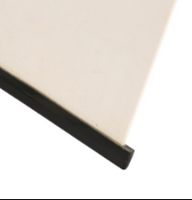
Shanghai Saiyi International Trading Co., Ltd. | Building Materials | Import & Export  Boathouse Materials
Shanghai Copious Industrial Co.,Ltd. | Building Materials | Import & Export  Industrial Materials | Shanghai Copious Industrial Co.,Ltd. is the agent of many internationally renowned companies such as Japan Kuraray Co., Ltd., and has maintained long-term and stable cooperation with many famous companies. The products of Copious Industrial mainly involve pesticides, pharmaceuticals, construction, electronics, textiles and other industries, and have the highest market share in the industry.

