Company Profile

COMPANY NAME: Boydak Dış Ticaret A.S.
(Member of Turkish Conglomerate Boydak Group that owns global Turkish Furniture brands: Istikbal- Bellona-Mondi-Deco, The Export Company of these)

WEBSITE:
www.boydakexport.com

YEAR OF ESTABLISHMENT: 2002 |  | NO OF EMLOYEES: More than 12,000 (Group companies)

1. ARE YOU INTERESTED IN: EXPORTING IMPORTING BOTH

2. descriBE the activity/PRODUCTS/SERVICES YOU SEEK TO PROMOTE
Sitting groups, dining rooms, bedrooms, home textiles, carpeting and accessories.
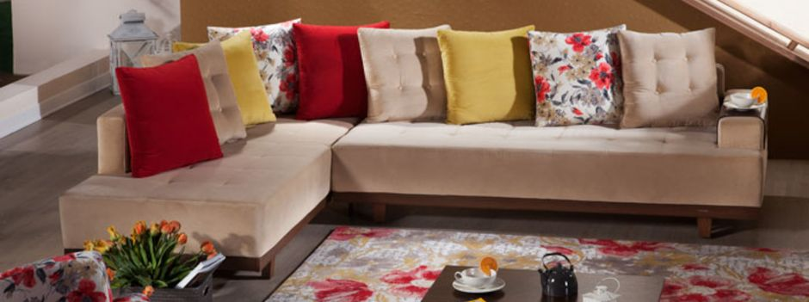
http://www.boydakexport.com/en/ecatalog (E-catalog link)

End consumer of your products:
- Households,
- Hotels,
- Turnkey Construction Companies (Hotels, Residential Units, Other)

Main applications of the product:
Living room, bedroom, dining room furnishes, home textile and accessories for

- Residential Units & Houses
- Hotels

3. COMMERCIAL PROFILE

Main factor of competitiveness of your company:

Design Price / quality
Quality Brand name / Presentation
Technology Range of product
Other (specify):

4. MARKET INFORMATION

What type of business contacts you are seeking:

Importer/Distributor/Wholesaler
Agent/Sales Representative
Franchising
Joint Venture Partner
License
Other (specify):

Is your company in contact with local companies? Yes No

Do you want to contact some specific companies? Yes No

If yes, specify the name and the address of the companies:

5. ADDITIONAL COMMENTS/INFORMATION ABOUT YOUR BUSINESS:

Boydak International Trade is the export channel for Istikbal, Bellona, Mondi and Deco brand furniture and accessories. We are proud to be a single source supplier of fine home furnishings including sitting groups, dining rooms, bedrooms, home textiles, carpeting and accessories. Each of our brands offers complete home decoration and furnishing solutions to distributors and retailers world wide.

Boydak is dedicated to providing total customer support to our global partners. Total customer support means providing high quality, customer preferred, trendsetting, functional, durable furniture. Each brand under the Boydak umbrella provides a rich selection of furniture for every room in the house. This means our global partners can mix their container with everything they need for the showroom floor from a single supplier source. Working directly with Boydak lets you ease your logistics issues right from the start. Take advantage of working with a global furniture giant to source everything you need on the showroom floor without the hassle of working with multiple suppliers.

