Company Profile

COMPANY NAME: Panelmo Mobilya San. Tic. Ltd. Şti.

WEBSITE:
www.idollife.com.tr
YEAR OF ESTABLISHMENT: 2011 |  | NO OF EMLOYEES: 105

1. ARE YOU INTERESTED IN: EXPORTING IMPORTING BOTH

2. descriBE the activity/PRODUCTS/SERVICES YOU SEEK TO PROMOTE
Bedroom furniture, dining room set, Sitting Groups (Armchairs, Sofas), Wall Units,

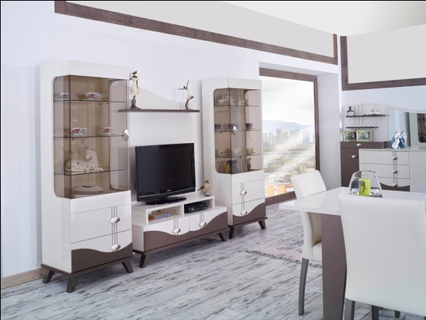
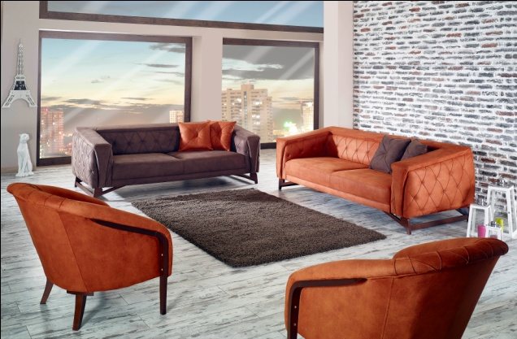
http://www.idollife.com.tr/e-katalog/index.html#/0 (link for E-catalog)

End consumer of your products:
- Households,
- Turnkey Construction Companies (Hotels, Residential Units),
- Hotels

Main applications of the product:
Living room, bedroom, dining room furnishes for
- Residential Units & Houses
- Hotels

3. COMMERCIAL PROFILE

Main factor of competitiveness of your company:

Design Price / quality
Quality Brand name / Presentation
Technology Range of product
Other (specify):

4. MARKET INFORMATION

What type of business contacts you are seeking:

Importer/Distributor/Wholesaler
Agent/Sales Representative
Franchising
Joint Venture Partner
License
Other (specify):

Is your company in contact with local companies? Yes No

Do you want to contact some specific companies? Yes No

If yes, specify the name and the address of the companies:

5. ADDITIONAL COMMENTS/INFORMATION ABOUT YOUR BUSINESS:

Our company established in 2011 at Kayseri, Organized Industrial Zone with an area of ​​8000 m2 facility; with 105 employees, we are producing Sofa, Chair, Corner Set , Bedroom furniture, dining room furniture.

Addition of production activities ; we have extended our products to customers with domestic sales network.

Our customers are the reason for our existence. Our company evolving market and customer expectations , technological developments, following the new production techniques and we aim to provide the best service at the best price .

