Join the second Baltic Investors Forum in June 2015
- 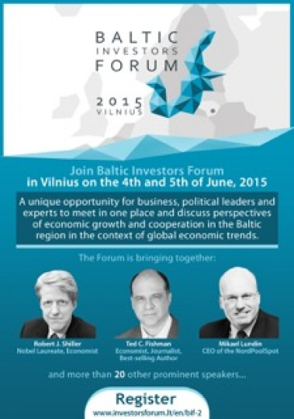

We kindly invite You to participate in the second “Baltic Investors Forum” (BIF 2015). The biannual event is going to take place in Vilnius on the 4th and 5th of June, 2015. BIF is a unique opportunity for business and political leaders as well as representatives of political parties and experts to meet in one place and discuss perspectives of economic growth and cooperation in the Baltic region in the context of global economic trends.
BIF 2015 offers ideas and perspectives from highly renowned speakers such as Nobel Prize Winner, Economist Robert J. Shiller, Ted Fishman – journalist and bestselling author, Servaas Deroose – Deputy Director general for the economic and financial affairs of the European Commission, Mantas Zalatorius – vice president of “Business Sweden”, Mikael Lundin – CEO of the “NordPoolSpot”, as well as others.
This year the main focus is future – what does the future look like and how should we prepare for the challenges awaiting. BIF 2015 will discuss the following themes: the upcoming global economy context, role of technological innovations in promoting economic competitiveness, “smart” cities, future innovations in transport, logistics, fuels and energy sectors, automated technologies.
One of the main BIF attractions is a unique B2B platform – meetings for companies and experts aiming at discussing business development and investment projects. Foreign business delegations coming to the meetings will be led by the Honorary Consuls of Lithuania.
Find out more: http://www.investorsforum.lt/en/bif-2
For more information please contact:
Andzelika Rusteikiene, „Investors Forum“
Mob. +370 624 57394, email: andzelika@investorsforum.lt
Register: http://www.investorsforum.lt/en/bif-2
Investors Forum is a business association of largest and most active investors in the Lithuanian economy aiming at improving Lithuanian investment and business environment. Founded in June of 1999, today Investors Forum has over 50 members including largest foreign investors in Lithuania: industrial, logistics and telecommunications companies, banks, as well as large business operating in other important areas.

